Stage 1 Lab - Human vs AI: Building Your First SmartCare Prototype

Learning objectives
- Create and run a simple Python file with basic input,output and processing statements
- Use lists, dictionaries and functions to enhance the Python file
- Build a small SmartCare appointment prototype.
- Use AI as a tutor rather than a replacement.
- Compare human-written and AI-generated code.
- Verify AI-generated code through execution and test inputs.
- Document a short AI-use reflection.

Files to create and commit in GitHub
stage01/
smartcare_v01.py
comparison.md
reflection.md
ai_usage.md

Part A - Understand the Problem: AI OFF
SmartCare needs a small prototype that allows a receptionist to record patient appointments. Each appointment records patient name, practitioner name and appointment time.
What data must be stored?
- Patient: first name, last name
- Practitioner: first name, last name
- Appointment: Patient, Practitioner, appointment date/time
What functions might be useful?
- View_patient_information(), create_patient(), edit_petient(), inactive_patient()
- View_practitioner_available(), mark_practitioner_unavailable()
- Create_appointment(), cancel_appointment(), attend_appointment()
What could go wrong?
- Duplicate patients with same name,
- duplicate appointments with the same practitioner,
- missing patient or appointment information,
- wrong patient, appointment information
What requirements are unclear?
- The workflow of cancelled appointment?
- Access levels (view/create/edit/delete) to different users (clinic admins, practitioners, clinic management)

Part B - Build a Human-Written Prototype: AI OFF
#task 1
# Create and run a simple Python file with basic input,output statements

print("Welcome to SmartCare: Community Clinic Appointment Booking System!")

# First Appointment
patient1_name = 'Alice Smith'
practitioner1_name = 'Dr. John Doe'
appointment1_time = '2024-07-20 10:00 AM'
print(f"Patient: {patient1_name} | Practitioner: {practitioner1_name} | Time: {appointment1_time}")

# Second Appointment
patient2_name = 'Bob Johnson'
practitioner2_name = 'Dr. Jane Roe'
appointment2_time = '2024-07-20 11:30 AM'
print(f"Patient: {patient2_name} | Practitioner: {practitioner2_name} | Time: {appointment2_time}")

#task1enhanced
# Use lists, dictionaries and functions to enhance the Python file

appointments = []

def book_appointment(patient_name, practitioner_name, appointment_time):
if not patient_name:
raise ValueError("Patient name cannot be empty")
appointment = {
"patient": patient_name,
"practitioner": practitioner_name,
"time": appointment_time
}
appointments.append(appointment)

def display_appointments():
if not appointments:
print("No appointments recorded.")
return
for appointment in appointments:
print(f"Patient: {appointment['patient']} | Practitioner: {appointment['practitioner']} | Time: {appointment['time']}")

print("Welcome to SmartCare: The Clinical Appointment Booking System!")
book_appointment('Alice Smith', 'Dr. John Doe', '2024-07-20 10:00 AM')
book_appointment('Bob Johnson', 'Dr. Jane Roe', '2024-07-20 11:30 AM')
display_appointments()

^ Now, run both programs , and identify at least five limitations.
Basic version:
- Repeated codes, if there are 1000 patients, the same code will repeat 1000 times
- No validation, patient and appointment input value is not checked type, null, invalid input value
- No structured appointment object, the appointment has no link to patient
- Hard to scale
- No structured database lists stored inputs and display the output
Enhanced version:
- Use reusable functions to get patient and appointment input
- Same validation, checked if patient name is empty
- Appointment linked to patient
- Possible to add/delete appointments to the appointments list
- Use the list to store and display appointments

Part C - Use AI as Tutor: AI ON (Use only UC approved GenAI Tool such as Microsoft CoPilot)
Suggested prompt structure:
Act as a Python tutor.
I am learning introductory software technology.
Here is a small appointment-booking function.
1. Explain what the code does.
The code is a simple SmartCare appointment booking script. It:
- Prints two hard-coded appointments.
- Defines a global `appointments` list.
- Provides `book_appointment()` to add appointments, validating only that the patient name is not empty.
- Provides `display_appointments()` to print all stored appointments.
- Books and displays appointments for Alice Smith and Bob Johnson.
2. Identify three limitations.
1. **Limited validation:** Only the patient name is checked; practitioner names and appointment times can be empty or invalid.
2. **No data persistence:** Appointments are stored only in memory and are lost when the program exits.
3. **No conflict or duplicate checking:** The system allows multiple appointments for the same practitioner or patient at the same time.
3. Suggest improvements.
1. Add validation for patient names, practitioner names, and appointment time formats.
2. Check for scheduling conflicts and prevent duplicate appointments.
3. Store appointments in a file or database so they persist after the program closes.
4. Add options to view, edit, cancel, and search appointments.
5. Replace hard-coded appointments with an interactive menu for user input.
6. Use classes or separate modules to improve structure and maintainability.
4. Do not rewrite the whole application.
5. Ask me two questions to test my understanding.
1. What validation should be added to ensure the practitioner name and appointment time are valid?
2. Why would saving appointments to a file or database improve this application?

Part D - Generate an Alternative: AI ON
Ask AI to create a simple beginner-friendly Python function that stores patient name, practitioner name and appointment time. Explicitly prohibit a database or GUI.
The existing `book_appointment` function already stores all three details, so I’ll keep the application intact and make that function explicitly beginner-friendly without adding a database or GUI.
Updated `book_appointment()` with a beginner-friendly explanation. It stores the patient name, practitioner name, and appointment time in a list.
No database or GUI was added.
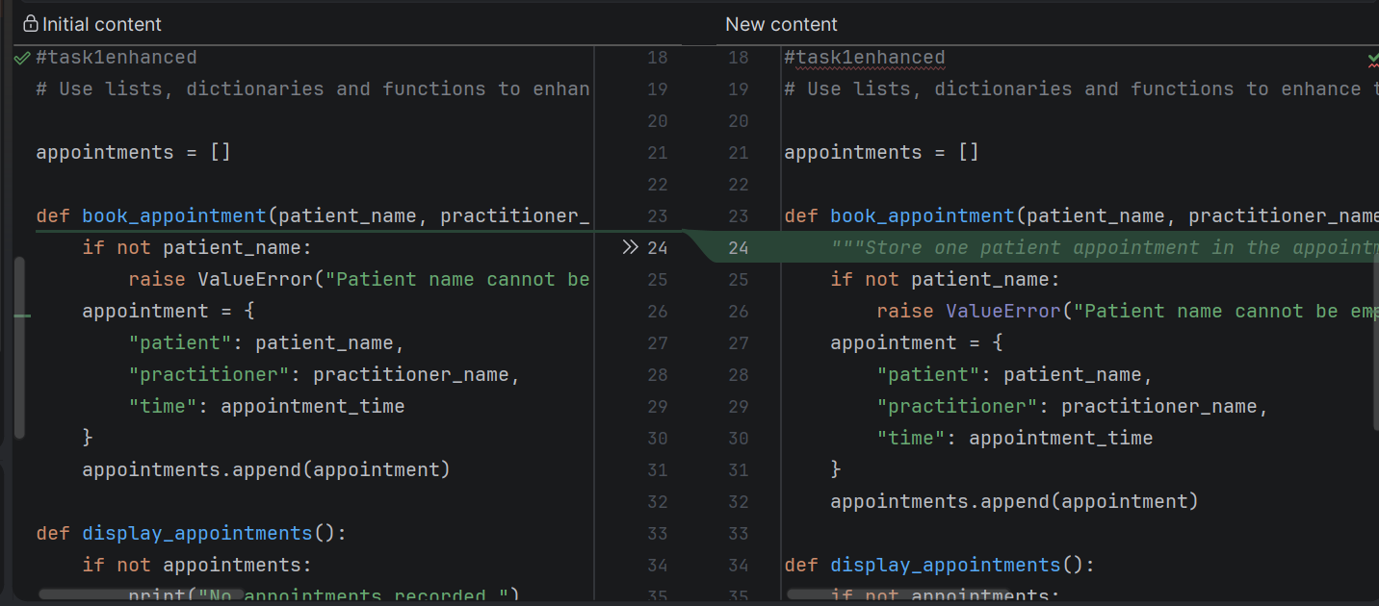

Part E - Compare Human and AI Versions
Question | Human version | AI version
Easy to understand? | Yes | Yes
Runs successfully? | Yes | Yes
Uses only required features? | Yes | Yes
Adds assumptions? | limit | Same limit
Handles errors? | limit | Same limit
Could I explain it? | Yes | Yes

Part F - Verify Behaviour
- Normal appointment
- Blank patient name
- Two appointments for the same practitioner/time
- Strange input such as patient_name=None or appointment_time=None

Part G - Improve One Thing
Choose exactly one controlled improvement, for example: if not patient_name: raise ValueError("Patient name cannot be empty")

Part H - Reflection (150-250 words)
What did you build before using AI?
What did AI help you understand?
Did AI make assumptions?
How did you verify the AI output?
What engineering work remained for you?
Before using AI, I built a basic Python script using standard input and output statements to handle two records. After identifying limitations in my initial code, I wrote an enhanced function to improve it.
When I shared my code with the AI (Copilot), it analyzed the functions, highlighted limitations, and suggested architectural improvements. By asking guiding questions, AI also helped me to understand the requirements better. Later, when I prompted it to "create a simple beginner-friendly Python function that stores patient name, practitioner name, and appointment time without a database or GUI," the AI simply added a single comment on line 24 explaining the subsequent code, leaving the core logic unchanged. Because no functional code was modified, the script still ran, but this highlighted that I needed to provide more detailed, specific prompts.
To verify the AI's output, I manually reviewed the suggested edits, tested whether the code was executed correctly, and evaluated if the logic aligned with my system requirements before deciding whether to accept or reject the changes. Ultimately, the engineering responsibility remained with me: formulating clear business rules, designing the underlying architecture, handling edge cases, and making final implementation decisions.

Submission checklist [GitHub Commit]
- Python file runs.
- Comparison table completed.
- Normal and unusual inputs tested.
- AI assistance documented.
- Reflection completed.
- I can explain my code.

